The Edible Cell
Goals: Students will build representations of cells using various food items to represent each organelle. Students will explain why they chose each food item and write the function of each organelle on the worksheet.
Materials Needed: Materials list, worksheet, picture of animal and plant cell, organelle notes,
Procedure:
Opener:
- Introduce activity by showing a square and round pie crust. Ask the students what kind of cell each crust should represent.
Development:
- Tell students to take out their pictures of plant and animal cells as well as their notes on the structure/function of the organelles.
- Place students into groups of 2 so that one gets a plant cell and the other gets an animal cell. This way, students can work together on their food choices and see how their partner's cell looks different from their own. Give each student a piece of saran wrap for their working space (and to wrap their completed cells) and then give them a square or round pie crust.
- Pass out the Edible Cell Worksheet. Explain the activity by giving students applesauce to spread on their pie crusts and ask them what organelle it represents. Students should realize the applesauce is "jelly-like" and should be the cytoplasm. Tell them to write down applesauce on their worksheets for cytoplasm.
- Show the students the various food stations and the list of foods on the board. Students are allowed to take a few of each kind of food and decide which organelle each food type will represent (the cookie makes a good nucleus, the Twizzlers make a good cell membrane, but not cell wall) and explain why they chose that food type (should be related to structure/function of that organelle). There is a lot of flexibility and creativity allowed!
- Students must show the teacher the completed (and correct) edible cells.
Closure:
- Students took a quiz on the structure/function of the cell organelles before they were allowed to eat it.
Evaluation: Students took a quiz on the structure/function of the cell organelles.
Extensions: Ask students what a prokaryote cell would look like. Have students write down (or make if you have the time and materials) what food they would use to make a model of a prokaryotic cell (which has no membrane-bound organelles, but does have things like a cell wall and cytoplasm).

Molecular Motion – Diffusion of Gases

Purpose
The purpose of this activity is to explain molecular theory and transportation of gases or diffusion.

Activity Description
Students will experience diffusion of aromatic liquids in the classroom.

Focus Question
How do gasses move through other matter?

Duration
One class period

Materials
- Small shallow dish or watch glass.
- Liquid that evaporates easily and has a distinct odor (perfume, cologne, vanilla, etc)

Teacher Preparation
- The pattern of hand-raising will be similar to waves in water. Those students who are close to the source of odor will raise their hands first; those students farther away will raise their hands later.
- The pattern of hand-raising will help to explain that the molecules of an evaporating substance must be transported by the movement of air molecules, that is, by the bouncing of air molecules against the molecules of the evaporating substance. The odor is caused by the millions of molecules of the substance being carried out in almost a wave motion to the olfactory nerves of the observers.

Classroom Procedure
- Fill an evaporating dish or watch glass with a liquid which evaporates easily and has a distinct odor.
- With all doors and windows closed to prevent drafts, the liquid is allowed to evaporate in the room.
- Participants are instructed to signal by raising their hands when they detect an odor.
- Observe the pattern of the hand raising throughout the room.
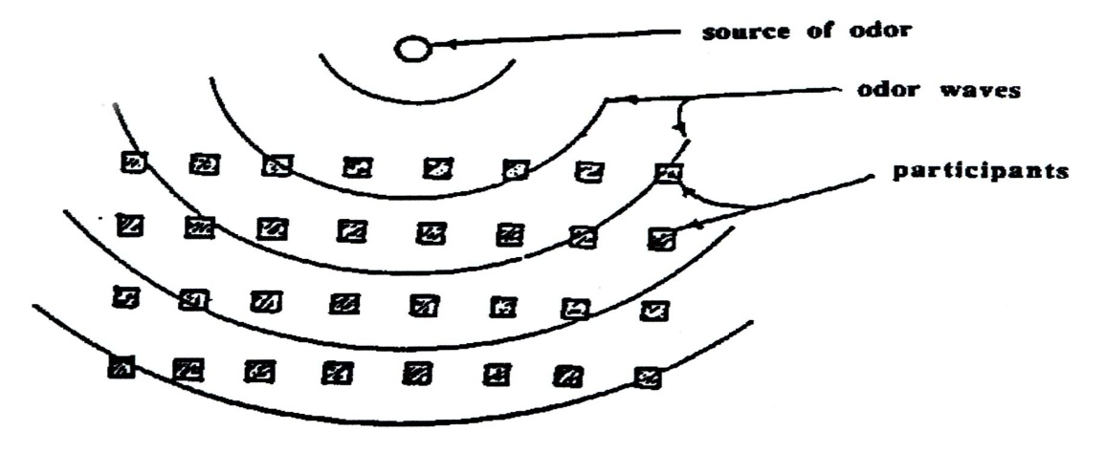
- The last person to raise his hand is asked to define the odor
AVG Velocity of Bowling Ball
Description: The goal of this experiment is to determine the velocity of a bowling ball based on measurements of displacement and time. We will use both an algebraic and a graphical approach to solve this problem.

Materials:
Bowling ball
Ramp (bowling ball launcher, car ramp, a board leaned on a chair, etc)
5 stop watches
Meter sticks
(Optional) Masking tape to mark the floor every 3 meters

Procedure:
Place the ball and ramp in the hallway outside the laboratory and aim it down the center of the hallway.

Position 5 people with stopwatches along the hallway so that they are 3 m apart. The first person should be located 3 m beyond the base of the launcher. Use pieces of tape to mark the locations of the timers and the base of the ramp.

Designate a sixth person to be in charge of releasing the ball.

Locate a seventh person beyond the last timer to stop the ball.

Designate an eighth person to collect data from all timers.

Three trials should be made from a single height on the ramp. The height should be noted and tape used to mark the launcher in order to get reproducible launches. (You may wish to have a few practice runs before collecting data).

When the ball reaches the floor all the timers should be started. As the ball passes each person with a stopwatch, they should stop their watch. The data should then be recorded in the below chart.

Repeat for three trials.
Data Collection:

∆x  t | 3m | 6m | 9m | 12m | 15m
trial 1
trial 2
trial 3

Students will Graph data to determine slope and avg. velocity at each location.
Gravitational Potential Energy Lesson

Hypothesis: How do you think the height from which a ball is dropped affects how high the ball will bounce? Explain. Think in terms of stored energy!
__________________________________________________________________________________________________________________________________________________________________________________________
Purpose: To experimentally investigate the relationship between an object’s gravitational potential energy and height above the ground.
Materials: lab sheet, bouncy ball, meter stick, calculator, pencil
Procedure:
- Tape the meter stick vertically against the wall. The meter stick should be supported without you having to hold it and allows you to measure how high the ball bounces.
- One person in your group should be in charge of dropping the ball. The other people in your group will be responsible for carefully observing the bounce height of the ball. Observers will need to be as close to eye level with the ball as possible.
- Hold the ball at the 50 cm mark and drop it from rest (do not throw it down).
- Observe how high the ball bounces on the first bounce. Record the height of the bounce in the data table below.
- Repeat steps 3 and 4 for a total of 5 trials. Calculate the average bounce height of trials 1-5.
- Repeat steps 3-5 for drop heights of 75 cm and 100 cm.
- Create a bar graph of Average Bounce Height (y-axis) vs Drop Height (x-axis)
Data:
Drop Height (cm) | Bounce Height #1 (cm) | Bounce Height #2 (cm) | Bounce Height #3 (cm) | Bounce Height #4 (cm) | Bounce Height #5 (cm) | Average Bounce Height (cm)
50
75
100

Bar Graph:
Average Bounce Height (cm) vs Drop Height (cm)

Questions:
- Was your hypothesis correct?
- Use your bar graph to explain how the bounce height is related to the drop height.
- How do you think gravitational potential energy is related to the bounce height in this investigation? Explain.
- If you were to make a bar graph of gravitational potential energy vs drop height, what would it look like?
- When did the ball have the most gravitational potential energy in this investigation and how did this affect bounce height? Explain your answer.
- How did you change the amount of gravitational potential energy the ball possessed in this investigation?
- What are other ways to change the amount of gravitational potential energy in an object?
- Suppose you wanted to make the ball bounce to a height of 1.5 m. Where would you drop it from and why? Explain your answer in terms of gravitational potential energy.
Inheritance and Test Crosses

Purpose:
To understand the concepts and purposes of testcrosses.

Materials at each station:
- File folder to attach genes
- Sticky notes with alleles
- Calculator

Procedure:
- Each group will be assigned to a station in the classroom.
- At each station, one person from the group must read the background information. This will help you determine the organism and traits (dominant/recessive) involved in the testcross.
- Determine the known parent’s genotype and as much of the unknown parent’s genotype and place these letters on the outside of the Punnett Square.
- Fill in the inside of the Punnett Square with as many letters as possible (just like we did in our slides!)
- Using what the situation says about the offspring, complete the rest of the testcross.
- Transfer all of the information onto the following pages of this worksheet. Make sure you are putting the information under the correct Station #.

Station 1
What organism is the statement about and what are the dominant and recessive traits?
What are the phenotypes of the parents in the testcross?

What are the genotypes of the parents?
Phenotype ratio of offspring:

Repeated for 6 Stations

